BLOGPOST - Start Up Your Startup Properly: TAM, SAM, SOM!

Start Up Your Startup Properly: TAM, SAM, SOM!
POSTED JUNE 26, 2018 ARTEM ALBUL

Introduction
Everyone knows that startup is born from an idea. Let’s assume that your idea is really unique, demanded by the market, it is difficult to copy1 by competitors and you have enough resources2 and passion for its implementation. So, what should be your first step to start up your startup?
You should start from TAM, SAM and SOM or, in other words, to assess the market potential for your product or service. By the way, this approach is correct for a product (service) launch too. Because startup in a broad sense is, actually, a product launch. So, if a company is going to launch a new product or service properly, it always starts from market evaluation and analysis.

¹Οr your idea is protected from illegal copying by a patent
²Money, time, people, technology and information.
Now let’s see what are TAM, SAM and SOM abbreviations stand for and what is the point behind these concepts?
Unfortunately, you will not find much valuable information with a clear explication, even Wikipedia article gives a rather vague explanation, in my opinion.
So, let's make it clear.
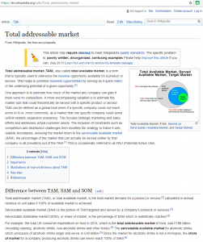
TAM, SAM and SOM Definitions
Total Available Market (TAM) or Total Addressable Market or Market Potential is the total sales volume of a particular product (or service) that can be sold by all vendors on the market worldwide (or a particular region, or a certain country) for the planned period (usually a year, a quarter or a month).
Serviceable Available Market (SAM) is the total sales volume of a particular product (or service) that can be sold by all vendors on the market within a territory that you are able to service for the planned period (usually a year, a quarter or a month).
Serviceable Obtainable Market (SOM) is the total sales volume of a particular product (or service) that can be sold by your company within a territory that you are able to service for the planned period (usually a year, a quarter or a month). “Can be sold” means realistic sales forecast made taking into account your production, logistic, sales and marketing capabilities, your competitors’ actions and influence, expected market trends and seasonality.
As can be seen from the definitions, SAM is a part of TAM. And SOM, in its turn, is a part of SAM.
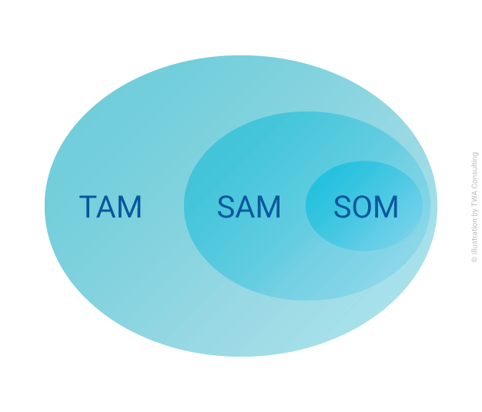
TAM, SAM and SOM can be calculated in sales units or in revenue.
The attentive reader noted that the definitions indicate a "planned period". It’s because generally TAM, SAM and SOM are the planned periodindicators and their main purpose is to show market opportunities.
If we talk about the reported period, in practice most likely you will come across such terms:
- TAM turns into Worldwide/Region/Country Market. But still sometimes TAM abbreviation used to designate the reported period, although this period is no longer “available”.
- SAM turns into Target Market,
- SOM - into Market Share.
To structure the information above and make it even clearer, let’s put it into the table:
Indicator abbreviation | Indicator transcription | Territory covered | Vendors included | In the reported period it, in practice, becomes
TAM | Total Available Market or Total Addressable Market | Worldwide or a particular region or a certain country | All vendors | Worldwide/Region/Country Market or TAM
SAM | Serviceable Available Market | Territory that you are able to service | All vendors | Target Market
SOM | Serviceable Obtainable Market | Territory that you are able to service | Your company only | Market Share
TAM, SAM and SOM Calculation and Forecast
So, since we have cleared up the meaning of these notions, the next obvious, but not trivial question is how to calculate, estimate and forecast TAM, SAM and SOM?
If you had been studying marketing in a college or university, than almost always you were given all the necessary data (as a rule, even in excess) while solving business cases: market volume by months, by product, by each competitor, etc. In real life this almost never happens, because detailed marketing research is very expensive, takes time and requires a certain amount of bureaucratic discussions, considerations and approvals within your organization (not to mention, that the cost of the required marketing research should be allocated in the annual budget plan in advance and approved by the company's management). Therefore, a vast majority of medium, small and even large companies (let's confess it) estimate market approximately, gathering information from open sources.
Since in this article I initially assumed that you are the founder of a startup, I will proceed forward with the assumption that you do not have money to buy detailed studies of your market.
So, what we can do in this situation?
1. Open Sources Analysis
In my mind, analysis of open sources will be the best solution in this situation.
Before you continue reading, please, be sure to read my article “The Value of Open Sources for Your Market Research”. I highly recommend reading it because there you will find many details necessary to understand the further text of this article.
Here is the list of open sources you should focus your search on:
- Industry analysts (e.g. GFK, IDC, Nielsen, Bloomberg, etc.);
- Industry media;
- Market leaders press releases and reports;
- Industry experts’ interviews, articles and posts;
- Existing and potential customers;
- Channel partners;
- Competitors.
You probably have already guessed that collecting and analyzing open sources:
- from paragraphs 1-4 — will help you to evaluate your TAM.
- from paragraphs 5-7— will help you to evaluate your SAM and SOM.
So, at this stage you already should have quite enough information to determine and forecast your TAM.
As for SAM and SOM, there may be situations in which open sources from paragraphs 5-7 may be unavailable or very limited. If so, then I would suggest you to assess your SAM and SOM using two main approaches: Bottom Up and Top Down.
2. Top Down Approach
The most popular is Top Down approach. Probably, because it seems easier in the calculations. Its idea is simple: having obtained an expert evaluation of your TAM from open sources, you reduce this figure, estimating how much will remain from TAM, if you remove the markets on the territory of which you cannot provide your services or goods. In this way you get estimation of your SAM. The next stage is estimation of SOM by reducing the SAM for the estimated sales of your competitors. Sounds very simple, but in fact it requires from you a very deep knowledge of your market.
The main drawback of this method is that your calculations may be too approximate (since they are mainly based on expert judgment, and not on exact mathematical calculations). And many executives, entrepreneurs and business owners fall into this trap. They reason nearly as follows: “From industry experts we know that TAM for our product in 2018 is expected approximately at the level of $500 billion, then having obtained only 0.1% of this market in a year, we will become a company with a turnover of $0.5 billion.” Assuming, of course, that 0.1% is a very conservative and easily achievable forecast. Angel investors have heard myriads of such “great ideas” during pitch meetings. The problem is that such a superficial calculation does not give answers on such essential questions as:
- How you are going to achieve your sales target?
- What resources you need to achieve the goal?
- What sales channels you are going to develop?
- Etc.
In other words, Top Down approach does not provide you enough information to develop your product strategy.
3. Bottom Up Approach
Bottom Up market assessment approach, on the contrary, provides enough information to develop your product strategy. However, its drawback is that more calculations are needed.
The idea of Bottom Up approach is that you start your calculation from the basic data about your business (your production volume, the price per unit, the number of potential customers, the average amount your potential customers spend each month on your products, and so on) and thus, step by step, you climb up to the potential (planned) volume of your sales (SOM). Adding to this figure calculation of sales volumes of your competitors (on the same territory) you will get SAM.
So, the Bottom Up method itself is much more complicated, because when using it in your calculation you anyway should answer questions that are mission critical for your product strategy development. But this characteristic is, actually, its advantage.
4. Which Approach to Use?
Perhaps the best option would be to use both approaches. Using Top Down you go down from the strategic level to the tactical one. And using Bottom Up you perform detailed calculations and rise from the operational level to the tactical one. If the final result of your Top Down and Bottom Up estimates have approximately coincided, then the reliability of your calculations and evaluations of SAM and SOM is quite high.
5. How to calculate emerging market, which is actually does not exist at the moment?
If you are going to create a new market by offering to people something they never saw, never used and never dreamt of, it means that you have to explain people why they need your product and, thus, form a buying habit, form demand. If you have clear solution on that challenge, than calculating this new market will be not so complicated.
First of all, you need to think what territory you are able to cover with your revolutionary product during the first year of sales. Than you need to estimate how many people within this area may in theory be interested in your product. Than take 16% from that figure – this is Innovators (2.5%) and Early Adopters (13.5%) – people who will buy your product first because of their customers’ behavior - they like to try new products. If they will be satisfied with the quality of your product, and if their expectations caused by your advertising are met (or exceeded), then you have a very good chance that after some time your product will attract a new group of customers called Early Majority (34%).
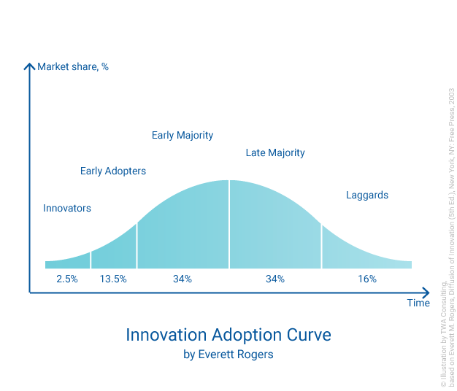
This is an optimistic forecast of the number of your customers. To turn it into revenue, you must multiply the number of potential customers calculated above by the ARPU (Average Revenue Per User).
ARPU * Quantity of potential customers worldwide = TAM (in Revenue)
ARPU consists of Product Revenue + Service Revenue (if any) per user for the specific period. For example, if you sell protective screen covers for smartphones, than your ARPU calculation for the period (i.e. day, week, month, quarter, year) will be the following:
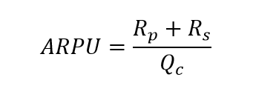
In this equation:
Rp - Total revenue from screen covers sold for the period,
Rs - Total revenue from mounting service for the period,
Qc - Total number of customers for the period.
6. Numerical example of TAM, SAM and SOM Estimation
Let's illustrate emerging market TAM, SAM and SOM calculations with an example. I give this example in a rather simplified form, just to illustrate my explanations. In practice, the assessment and calculations should be much more detailed.
Say, it’s early 2000’s and your revolutionary product is a wristband fitness tracker that you plan to sell in the USA with a reasonable margin (to cover your R&D expenses and marketing investments to create demand) at a price of $50 per unit. It’s a new market, new product, no statistics, no user experience and no demand.
TAM estimation
Your primary and core target audience (potential customers): people having health club or fitness club membership.
Total worldwide number of people having health club or fitness club membership according to the open source: ≈ 100 million people. This is your TAM in units.
Your ARPU equals to the product price = $50.
Your TAM in Revenue = $50 * 100,000,000 = $5,000,000,000
SAM estimation
Since you plan to run sales within the USA territory only, you need to estimate total number of people having health club or fitness club membership in the US. According to the open source, this number is ≈ 50 million people. This is your SAM in units.
Your SAM in revenue = $50 * 50,000,000 = $2,500,000,000
SOM estimation
You expect that competitors will appear very quickly (within the first month of your sales) and will grab approximately 50% of the US market within the first year of sales. Also, you (together with your competitors) will create demand conducting extensive marketing campaigns. As a result of your marketing efforts, a small part of your target audience (Innovators – 2.5%) will buy your product. If, based on the results of the first experience of using your product, the perception of your product by the market is positive, then the next group of customers (Early Adopters – 13.5%) will become ready to buy.
So, the calculations are as follows:
SOM in units = 50,000,000 * 50% * (2.5% + 13.5%) = 4,000,000 people
SOM in revenue = $50 * 4,000,000 = $20,000,000
TAM, SAM, SOM through Investors' Eyes
First of all, investors are interested to fund startups with ROI3 higher than investors’ MARR4 with the least possible risks. Investors evaluate ROI by assessing your business plan, which must contain your short-term and long-term goals, as well as your strategy describing how you are going to achieve your objectives. In order to prepare an appropriate business plan, you need those SAM and SOM evaluations I have been explaining above.
Secondly, investors evaluate your ability to adequately assess the competitive environment. The logic behind your SAM and SOM estimates in your business plan will show investors your ability to assess the influence of competitors and how you plan to rival with them.
Thirdly, investors are interested in scalable business idea. The idea must have growth potential. So, investors pay attention to your TAM estimation.

3Return On Investment
4Minimum Acceptable Rate of Return
Summary
TAM, SAM and SOM play an important role in the process of assessing the market when you need to prepare a startup business plan or to launch a new product on the market. Each of them is important:
- TAM – allows you to assess global prospects and opportunities for business expansion.
- SOM – reflects your short-term realistic sales goals. Besides, in the process of collecting information and preparing calculations it helps to develop a product strategy.
- SAM – helps to assess the influence of competitors.
In addition, the ratio of SOM / SAM – shows your market share on the territory that you are able to service, and the ratio of SOM / TAM – your worldwide market share.
All three indicators play an important role in preparing your business plan, product strategy and in assessing your investment opportunity. To ensure your success, it is very important to concentrate your attention not on the size of their values, but on their accuracy.

Aus <https://thewiseadvice.com/marketing/2018/start-up-your-startup-properly-tam-sam-som/>

